AZ-204 Examen training

# Question 1

You are implementing a software as a service (SaaS) ASP.NET Core web service that will run as an Azure Web App. The web service will use an on-premises  
SQL Server database for storage. The web service also includes a WebJob that processes data updates. Four customers will use the web service.

* Each instance of the WebJob processes data for a single customer and must run as a singleton instance.
* Each deployment must be tested by using deployment slots prior to serving production data.
* Azure costs must be minimized.
* Azure resources must be located in an isolated network.

You need to configure the App Service plan for the Web App.  
How should you configure the App Service plan? To answer, select the appropriate settings in the answer area.

Number of VM instances: 2, 4, 8, 16?

|  |  |
| --- | --- |
| A | 2 |
| B | 4 |
| C | 8 |
| D | 16 |

Pricing Tier: Isolated, Standard, Premium, Consumption?

|  |  |
| --- | --- |
| A | Isolated |
| B | Standard |
| C | Premium |
| D | Consumption |

# Answer

B, A

# Explanation

Box 1: 4

There are four customers that use this service, and each instance of the WebJob processes data for a single customer and must run as a singleton instance. So, the number of VM should be 4. WebJobs is a feature of Azure App Service that enables you to run a program or script in the same instance as a web app. Like running background tasks.

Box 2: Isolated

Azure resources must be located in an isolated network.

In the Isolated tier, the App Service Environment defines the number of isolated workers that run your apps, and each worker is charged. In addition, there's a flat Stamp Fee for the running the App Service Environment itself. Isolated: This tier runs dedicated Azure VMs on dedicated Azure Virtual Networks. It provides network isolation on top of compute isolation to your apps. It provides the maximum scale-out capabilities.

Note. You can have several deployment slots within the same instance so you don't need 8 instances for it but 4.

For plans see: <https://azure.microsoft.com/en-us/pricing/details/app-service/windows/>

# Question 2

DRAG DROP -

You develop an Azure solution that uses Cosmos DB.

The current Cosmos DB container must be replicated and must use a partition key that is optimized for queries.

You need to implement a change feed processor solution.

Which change feed processor components should you use? To answer, drag the appropriate components to the correct requirements. Each component may be used once, more than once, or not at all. You may need to drag the split bar between panes or scroll to view the content.

NOTE: Each correct selection is worth one point.

Select and Place:

|  |  |
| --- | --- |
| Requirement | Component |
| Store the data from which the change feed is generated |  |
| Coordinate processing of the change feed across multiple workers |  |
| Use the change feed processor to listen for changes |  |
| Handle each batch of changes |  |

|  |  |
| --- | --- |
| Components | |
| A | Host |
| B | Delegate |
| C | Lease Container |
| D | Monitored container |

# Answer

D, C, A, B

# Explanation

Box 1: The monitored container -

The monitored container has the data from which the change feed is generated. Any inserts and updates to the monitored container are reflected in the change feed of the container.

Box 2: The lease container -

The lease container acts as a state storage and coordinates processing the change feed across multiple workers. The lease container can be stored in the same account as the monitored container or in a separate account.

Box 3: The host: A host is an application instance that uses the change feed processor to listen for changes. Multiple instances with the same lease configuration can run in parallel, but each instance should have a different instance name.

Box 4: The delegate -

The delegate is the code that defines what you, the developer, want to do with each batch of changes that the change feed processor reads.

Reference:

https://docs.microsoft.com/en-us/azure/cosmos-db/change-feed-processor

# Question 3

You are creating a CLI script that creates an Azure web app and related services in Azure App Service. The web app uses the following variables:

|  |  |
| --- | --- |
| Variable name | Value |
| $gitrepo | <https://github.com/Contos/webapp> |
| $webappname | Webapp1103 |

You need to automatically deploy code from GitHub to the newly created web app.

How should you complete the script? To answer, select the appropriate options in the answer area.

Answer area:

az group create –location westeurope –name myResourcegroup

|  |  |  |
| --- | --- | --- |
| A | az webapp | --name $webappname –resource-group myResourceGroup –sku FREE |
| B | az appservice plan create |
| C | az webapp deployment |
| D | az group delete |

|  |  |  |  |  |
| --- | --- | --- | --- | --- |
| A | az webapp create | --name $webappname –resource-group myResourceGroup | A | --repo-url $gitrepo –branch master –manual-integration |
| B | az appservice plan create | B | Git clone $gitrepo |
| C | az webapp deployment | C | --plan $webappname |
| D | az group delete |  |  |

|  |  |  |  |  |
| --- | --- | --- | --- | --- |
| A | az webapp | source config –name $webappname –resource-group myResourceGroup | A | --repo-url $gitrepo –branch master –manual-integration |
| B | az appservice plan create | B | Git clone $gitrepo |
| C | az webapp deployment | C | --plan $webappname |
| D | az group delete |  |  |

# Answer

B, A, C, C, A

# Explanation

1. Create a resource group
2. Create a service Plan
3. Create the webapp
4. Add the deployment

# Question 4

Note: This question is part of a series of questions that present the same scenario. Each question in the series contains a unique solution that might meet the stated goals. Some question sets might have more than one correct solution, while others might not have a correct solution.

After you answer a question in this section, you will NOT be able to return to it. As a result, these questions will not appear in the review screen.

You develop a software as a service (SaaS) offering to manage photographs. Users upload photos to a web service which then stores the photos in Azure

Storage Blob storage. The storage account type is General-purpose V2.

When photos are uploaded, they must be processed to produce and save a mobile-friendly version of the image. The process to produce a mobile-friendly version of the image must start in less than one minute.

You need to design the process that starts the photo processing.

Solution: Trigger the photo processing from Blob storage events.

Does the solution meet the goal?

|  |  |
| --- | --- |
| **A** | Yes |
| **B** | No |

# Answer

B

# Explanation

When running on a Consumption Plan there can be a delay of 10 minutes. (See <https://docs.microsoft.com/en-us/azure/azure-functions/functions-bindings-storage-blob-trigger?tabs=csharp#event-grid-trigger> )

Better use the event grid here ( <https://docs.microsoft.com/en-us/azure/event-grid/resize-images-on-storage-blob-upload-event?tabs=dotnet%2Cazure-powershell>)

# Question 5

You develop a software as a service (SaaS) offering to manage photographs. Users upload photos to a web service which then stores the photos in Azure

Storage Blob storage. The storage account type is General-purpose V2.

When photos are uploaded, they must be processed to produce and save a mobile-friendly version of the image. The process to produce a mobile-friendly version of the image must start in less than one minute.

You need to design the process that starts the photo processing.

Solution: Move photo processing to an Azure Function triggered from the blob upload.

Does the solution meet the goal?

|  |  |
| --- | --- |
| **A** | Yes |
| **B** | No |

# Answer

A

# Explanation

Azure Storage events allow applications to react to events. Common Blob storage event scenarios include image or video processing, search indexing, or any file- oriented workflow.

Events are pushed using Azure Event Grid to subscribers such as Azure Functions, Azure Logic Apps, or even to your own http listener.

Note: Only storage accounts of kind StorageV2 (general purpose v2) and BlobStorage support event integration. Storage (general purpose v1) does not support integration with Event Grid.

Question 6

You develop a software as a service (SaaS) offering to manage photographs. Users upload photos to a web service which then stores the photos in Azure

Storage Blob storage. The storage account type is General-purpose V2.

When photos are uploaded, they must be processed to produce and save a mobile-friendly version of the image. The process to produce a mobile-friendly version of the image must start in less than one minute.

You need to design the process that starts the photo processing.

Solution: Create an Azure Function app that uses the Consumption hosting model and that is triggered from the blob upload.

Does the solution meet the goal?

|  |  |
| --- | --- |
| **A** | Yes |
| **B** | No |

Answer

B

Explanation

When running on a Consumption Plan there can be a delay of 10 minutes. (See <https://docs.microsoft.com/en-us/azure/azure-functions/functions-bindings-storage-blob-trigger?tabs=csharp#event-grid-trigger> )

Better use the event grid here ( <https://docs.microsoft.com/en-us/azure/event-grid/resize-images-on-storage-blob-upload-event?tabs=dotnet%2Cazure-powershell>)

# Question 7

You develop and deploy an Azure App Service API app to a Windows-hosted deployment slot named Development. You create additional deployment slots named Testing and Production. You enable auto swap on the Production deployment slot.

You need to ensure that scripts run and resources are available before a swap operation occurs.

Solution: Update the web.config file to include the applicationInitialization configuration element. Specify custom initialization actions to run the scripts.

Does the solution meet the goal?

|  |  |
| --- | --- |
| **A** | Yes |
| **B** | No |

# Answer

A

# Explanation

IIS Only!! Specify custom warm-up.

Some apps might require custom warm-up actions before the swap. The applicationInitialization configuration element in web.config lets you specify custom initialization actions. The swap operation waits for this custom warm-up to finish before swapping with the target slot. Here's a sample web.config fragment.

<system.webServer>

<applicationInitialization>

<add initializationPage="/" hostName="[app hostname]" />

<add initializationPage="/Home/About" hostName="[app hostname]" />

</applicationInitialization>

</system.webServer>

Reference:

<https://docs.microsoft.com/en-us/azure/app-service/deploy-staging-slots#swap-operation-steps>

Question 8

You develop a software as a service (SaaS) offering to manage photographs. Users upload photos to a web service which then stores the photos in Azure

Storage Blob storage. The storage account type is General-purpose V2.

When photos are uploaded, they must be processed to produce and save a mobile-friendly version of the image. The process to produce a mobile-friendly version of the image must start in less than one minute.

You need to design the process that starts the photo processing.

Solution: Use the Azure Blob Storage change feed to trigger photo processing.

Does the solution meet the goal?

|  |  |
| --- | --- |
| **A** | Yes |
| **B** | No |

Answer

B

Explanation

The change feed is a log of changes that are organized into hourly segments but appended to and updated every few minutes. These segments are created only when there are blob change events that occur in that hour.

Instead catch the triggered event, so move the photo processing to an Azure Function triggered from the blob upload.

Reference:

<https://docs.microsoft.com/en-us/azure/storage/blobs/storage-blob-change-feed>

<https://docs.microsoft.com/en-us/azure/storage/blobs/storage-blob-event-overview>

# Question 9

You develop and deploy an Azure App Service API app to a Windows-hosted deployment slot named Development. You create additional deployment slots named Testing and Production. You enable auto swap on the Production deployment slot.

You need to ensure that scripts run and resources are available before a swap operation occurs.

Solution: Enable auto swap for the Testing slot. Deploy the app to the Testing slot.

Does the solution meet the goal?

|  |  |
| --- | --- |
| **A** | Yes |
| **B** | No |

# Answer

B

# Explanation

No triggers to run scripts.

Some apps might require custom warm-up actions before the swap. The applicationInitialization configuration element in web.config lets you specify custom initialization actions. The swap operation waits for this custom warm-up to finish before swapping with the target slot. Here's a sample web.config fragment.

<system.webServer>

<applicationInitialization>

<add initializationPage="/" hostName="[app hostname]" />

<add initializationPage="/Home/About" hostName="[app hostname]" />

</applicationInitialization>

</system.webServer>

Reference:

<https://docs.microsoft.com/en-us/azure/app-service/deploy-staging-slots#swap-operation-steps>

# Question 10

You develop and deploy an Azure App Service API app to a Windows-hosted deployment slot named Development. You create additional deployment slots named Testing and Production. You enable auto swap on the Production deployment slot.

You need to ensure that scripts run and resources are available before a swap operation occurs.

Solution: Disable auto swap. Update the app with a method named statuscheck to run the scripts. Re-enable auto swap and deploy the app to the Production slot.

Does the solution meet the goal?

|  |  |
| --- | --- |
| **A** | Yes |
| **B** | No |

# Answer

A

# Explanation

You can also customize the warm-up behavior with one or both of the following app settings:

* WEBSITE_SWAP_WARMUP_PING_PATH: The path to ping over HTTP to warm up your site. Add this app setting by specifying a custom path that begins with a slash as the value. An example is /statuscheck. The default value is /.
* WEBSITE_SWAP_WARMUP_PING_STATUSES: Valid HTTP response codes for the warm-up operation. Add this app setting with a comma-separated list of HTTP codes. An example is 200,202 . If the returned status code isn't in the list, the warmup and swap operations are stopped. By default, all response codes are valid.
* WEBSITE_WARMUP_PATH: A relative path on the site that should be pinged whenever the site restarts (not only during slot swaps). Example values include /statuscheck or the root path, /.

Reference:

<https://docs.microsoft.com/en-us/azure/app-service/deploy-staging-slots#specify-custom-warm-up>

# Question 11

You develop and deploy an Azure App Service API app to a Windows-hosted deployment slot named Development. You create additional deployment slots named Testing and Production. You enable auto swap on the Production deployment slot.

You need to ensure that scripts run and resources are available before a swap operation occurs.

Solution: Update the app with a method named statuscheck to run the scripts. Update the app settings for the app. Set the

WEBSITE_SWAP_WARMUP_PING_PATH and WEBSITE_SWAP_WARMUP_PING_STATUSES with a path to the new method and appropriate response codes.

Does the solution meet the goal?

|  |  |
| --- | --- |
| **A** | Yes |
| **B** | No |

# Answer

A

# Explanation

From Microsoft: <https://docs.microsoft.com/en-us/azure/app-service/deploy-staging-slots>

You can also customize the warm-up behavior with one or both of the following app settings:

WEBSITE_SWAP_WARMUP_PING_PATH: The path to ping to warm up your site. Add this app setting by specifying a custom path that begins with a slash as the value. An example is /statuscheck. The default value is /.

WEBSITE_SWAP_WARMUP_PING_STATUSES: Valid HTTP response codes for the warm-up operation. Add this app setting with a comma-separated list of HTTP codes. An example is 200,202 . If the returned status code isn't in the list, the warmup and swap operations are stopped. By default, all response codes are valid.

WEBSITE_WARMUP_PATH: A relative path on the site that should be pinged whenever the site restarts (not only during slot swaps). Example values include /statuscheck or the root path, /.

# Question 12

You are developing a serverless Java application on Azure. You create a new Azure Key Vault to work with secrets from a new Azure Functions application.

The application must meet the following requirements:

* Reference the Azure Key Vault without requiring any changes to the Java code.
* Dynamically add and remove instances of the Azure Functions host based on the number of incoming application events.
* Ensure that instances are perpetually warm to avoid any cold starts.
* Connect to a VNet.
* Authentication to the Azure Key Vault instance must be removed if the Azure Function application is deleted.

You need to grant the Azure Functions application access to the Azure Key Vault.

Which three actions should you perform in sequence? To answer, move the appropriate actions from the list of actions to the answer area and arrange them in the correct order.

|  |  |
| --- | --- |
| **A** | Create a user-assigned managed identity for the application |
| **B** | Create the Azure Function app with a Premium plan type |
| **C** | Create an access policy in Azure Key Vault for the application identity |
| **D** | Create an SSL certification in Azure Key Vault for the application identity |
| **E** | Create the Azure Function app with an App Service plan type |
| **F** | Create the Azure Function app with a Consumption plan type |
| **G** | Create a system-assigned managed identity for the application |

# Answer

B, G, C

# Explanation

Step 1: Create the Azure Functions app with a Premium plan type

Premium plan automatically scales based on demand using pre-warmed workers which run applications with no delay after being idle, runs on more powerful instances, and connects to virtual networks.

Step 2: Create a system-assigned managed identity for the application

When you enable a system-assigned managed identity an identity is created in Azure AD that is tied to the lifecycle of that service instance. So when the resource is deleted, Azure automatically deletes the identity for you. Key Vault references currently only support system-assigned managed identities. User-assigned identities cannot be used.

Step 3: Create an access policy in Key Vault for the application identity

Create an Access Policy in Key Vault for the application identity you created earlier. Enable the "Get" secret permission on this policy.

<https://docs.microsoft.com/en-us/azure/azure-functions/functions-scale>

# Question 13

You develop a website. You plan to host the website in Azure. You expect the website to experience high traffic volumes after it is published.

You must ensure that the website remains available and responsive while minimizing cost.

You need to deploy the website.

What should you do?

|  |  |
| --- | --- |
| **A** | Deploy the website to a virtual machine. Configure the virtual machine to automatically scale when the CPU load is high. |
| **B** | Deploy the website to an App Service that uses the Shared service tier. Configure the App Service plan to automatically scale when the CPU load is high. |
| **C** | Deploy the website to a virtual machine. Configure a Scale Set to increase the virtual machine instance count when the CPU load is high. |
| **D** | Deploy the website to an App Service that uses the Standard service tier. Configure the App Service plan to automatically scale when the CPU load is high. |

# Answer

D

# Explanation

Windows Azure Web Sites (WAWS) offers 3 modes: Standard, Free, and Shared.

Standard mode carries an enterprise-grade SLA (Service Level Agreement) of 99.9% monthly, even for sites with just one instance.

Standard mode runs on dedicated instances, making it different from the other ways to buy Windows Azure Web Sites.

Incorrect Answers:

B: Shared and Free modes do not offer the scaling flexibility of Standard, and they have some important limits.

Shared mode, just as the name states, also uses shared Compute resources, and also has a CPU limit. So, while neither Free nor Shared is likely to be the best choice for your production environment due to these limits.

Question 14

You have a web service that is used to pay for food deliveries. The web service uses Azure Cosmos DB as the data store.

You plan to add a new feature that allows users to set a tip amount. The new feature requires that a property named tip on the document in Cosmos DB must be present and contain a numeric value.

There are many existing websites and mobile apps that use the web service that will not be updated to set the tip property for some time.

How should you complete the trigger?

function ensureTip()

{

|  |  |
| --- | --- |
| **A** | var r = __.value(); |
| **B** | var r = __.readDocument(‘item’); |
| **C** | var r = getContext().getRequest(); |
| **D** | var r = getContext().getResponse(); |

var I = r.getBody();

|  |  |
| --- | --- |
| **A** | if (!(“tip” in i) {  i[“tip”] = 0;  } |
| **B** | if (request.getValue(“tip”) === null) {  i[“tip”] = 0;  } |
| **C** | if (isNaN(i[“tip”]) || i[“tip”] === null) {  i[“tip”] = 0;  } |
| **D** | If (typeof __pluck(“tip”) == ‘number’) {  i[“tip”] = 0;  } |

|  |  |
| --- | --- |
| **A** | r.setBody(i); |
| **B** | r.setValue(i); |
| **C** | __.upsertDocument(i); |
| **D** | __.replaceDocument(i); |

}

# Answer

C, C, A

# Question 15

You develop an HTTP triggered Azure Function app to process Azure Storage blob data. The app is triggered using an output binding on the blob.

The app continues to time out after four minutes. The app must process the blob data.

You need to ensure the app does not time out and processes the blob data.

Solution: Use the Durable Function async pattern to process the blob data.

Does the solution meet the goal?

|  |  |
| --- | --- |
| **A** | Yes |
| **B** | No |

# Answer

A

# Explanation:

Regardless of the function app timeout setting, 230 seconds is the maximum amount of time that an HTTP triggered function can take to respond to a request. This is because of the default idle timeout of Azure Load Balancer. For longer processing times, consider using the Durable Functions async pattern or defer the actual work and return an immediate response.

<https://docs.microsoft.com/en-us/azure/azure-functions/functions-scale#timeout>

# Question 16

You develop an HTTP triggered Azure Function app to process Azure Storage blob data. The app is triggered using an output binding on the blob.

The app continues to time out after four minutes. The app must process the blob data.

You need to ensure the app does not time out and processes the blob data.

Solution: Pass the HTTP trigger payload into an Azure Service Bus queue to be processed by a queue trigger function and return an immediate HTTP success response.

Does the solution meet the goal?

|  |  |
| --- | --- |
| **A** | Yes |
| **B** | No |

# Answer

A

# Explanation

Large, long-running functions can cause unexpected timeout issues. General best practices include:

Whenever possible, refactor large functions into smaller function sets that work together and return responses fast. For example, a webhook or HTTP trigger function might require an acknowledgment response within a certain time limit; it's common for webhooks to require an immediate response. You can pass the

HTTP trigger payload into a queue to be processed by a queue trigger function. This approach lets you defer the actual work and return an immediate response.

# Question 17

You develop an HTTP triggered Azure Function app to process Azure Storage blob data. The app is triggered using an output binding on the blob.

The app continues to time out after four minutes. The app must process the blob data.

You need to ensure the app does not time out and processes the blob data.

Solution: Configure the app to use an App Service hosting plan and enable the Always On setting.

Does the solution meet the goal?

|  |  |
| --- | --- |
| **A** | Yes |
| **B** | No |

# Answer

B

# Explanation:

Always On enables waking up on HTTPTrigger, but does not prevent the exceeding the max time out time of 230 seconds

# Question 18

You are developing an application that uses Azure Blob storage.

The application must read the transaction logs of all the changes that occur to the blobs and the blob metadata in the storage account for auditing purposes. The changes must be in the order in which they occurred, include only create, update, delete, and copy operations and be retained for compliance reasons.

You need to process the transaction logs asynchronously.

What should you do?

|  |  |
| --- | --- |
| **A** | Process all Azure Blob storage events by using Azure Event Grid with a subscriber Azure Function app. |
| **B** | Enable the change feed on the storage account and process all changes for available events. |
| **C** | Process all Azure Storage Analytics logs for successful blob events. |
| **D** | Use the Azure Monitor HTTP Data Collector API and scan the request body for successful blob events. |

# Answer

B

# Explanation

Change feed support in Azure Blob Storage

The purpose of the change feed is to provide transaction logs of all the changes that occur to the blobs and the blob metadata in your storage account. The change feed provides ordered, guaranteed, durable, immutable, read-only log of these changes. Client applications can read these logs at any time, either in streaming or in batch mode. The change feed enables you to build efficient and scalable solutions that process change events that occur in your Blob Storage account at a low cost.

Reference:

# Question 19

You plan to create a Docker image that runs an ASP.NET Core application named ContosoApp. You have a setup script named setupScript.ps1 and a series of application files including ContosoApp.dll.

You need to create a Dockerfile document that meets the following requirements:

* Call setupScripts.ps1 when the container is built.
* Run ContosoApp.dll when the container starts.

The Dockerfile document must be created in the same folder where ContosoApp.dll and setupScript.ps1 are stored.

Which five commands should you use to develop the solution? To answer, move the appropriate commands from the list of commands to the answer area and arrange them in the correct order.

Select and Place:

|  |  |
| --- | --- |
| **A** | FROM microsoft/aspnetcore-build:latest |
| **B** | RUN powershell ./setupScript.ps1 |
| **C** | WORKDIR /apps/ContosoApp |
| **D** | CMD ["dotnet", "aspnetapp.dll"] |
| **E** | COPY ./ . |

# Answer

A, C, E, B, D

# Explanation:

# Question 20

You are developing an Azure Function App by using Visual Studio. The app will process orders input by an Azure Web App. The web app places the order information into Azure Queue Storage.

You need to review the Azure Function App code shown below.

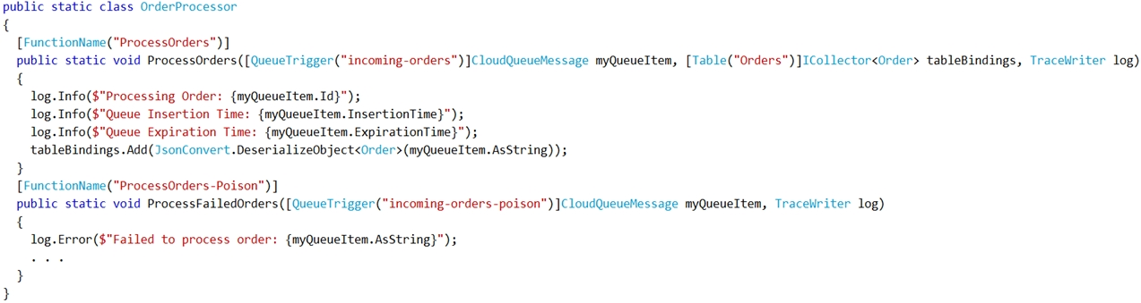

NOTE: Each correct selection is worth one point.

# 

(Yes = A, No = B)

# Answer

B, A, A, A (No, Yes, Yes, Yes)

# Explanation

Box 1: ExpirationTime - The time that the message expires. InsertionTime - The time that the message was added to the queue.

Box 2: maxDequeueCount - The number of times to try processing a message before moving it to the poison queue. Default value is 5.

Box 3: When there are multiple queue messages waiting, the queue trigger retrieves a batch of messages and invokes function instances concurrently to process them.

By default, the batch size is 16. When the number being processed gets down to 8, the runtime gets another batch and starts processing those messages. So the maximum number of concurrent messages being processed per function on one virtual machine (VM) is 24.

Box 4:

https://docs.microsoft.com/en-us/azure/azure-functions/functions-bindings-storage-queue

# Question 21

You are developing a solution for a hospital to support the following use cases:

* The most recent patient status details must be retrieved even if multiple users in different locations have updated the patient record.
* Patient health monitoring data retrieved must be the current version or the prior version.
* After a patient is discharged and all charges have been assessed, the patient billing record contains the final charges.

You provision a Cosmos DB NoSQL database and set the default consistency level for the database account to Strong. You set the value for Indexing Mode to

Consistent.

You need to minimize latency and any impact to the availability of the solution. You must override the default consistency level at the query level to meet the required consistency guarantees for the scenarios.

Which consistency levels should you implement? To answer, drag the appropriate consistency levels to the correct requirements. Each consistency level may be used once, more than once, or not at all. You may need to drag the split bar between panes or scroll to view content.

Select and Place:

|  |  |  |  |
| --- | --- | --- | --- |
| **A** | Strong |  | Return the most recent patient status. |
| **B** | Consistent Prefix | Return health monitoring data that is no less than one version behind |
| **C** | Bounded Staleness | After patient is discharged and all charges are assessed, retrieve the correct billing data with the final charges |
| **D** | Eventual |  |

# Answer

A, C, D (Strong, Bounded staleness, Eventual)

# Explanation:

Box 1: Strong -

Strong: Strong consistency offers a linearizability guarantee. The reads are guaranteed to return the most recent committed version of an item. A client never sees an uncommitted or partial write. Users are always guaranteed to read the latest committed write.

Box 2: Bounded staleness -

Bounded staleness: The reads are guaranteed to honor the consistent-prefix guarantee. The reads might lag behind writes by at most "K" versions (that is

"updates") of an item or by "t" time interval. When you choose bounded staleness, the "staleness" can be configured in two ways:

The number of versions (K) of the item

The time interval (t) by which the reads might lag behind the writes

Box 3: Eventual -

Eventual: There's no ordering guarantee for reads. In the absence of any further writes, the replicas eventually converge.

Incorrect Answers:

Consistent prefix: Updates that are returned contain some prefix of all the updates, with no gaps. Consistent prefix guarantees that reads never see out-of-order writes.

# Question 22

A company is developing a Node.js web app. The web app code is hosted in a GitHub repository located at https://github.com/TailSpinToys/webapp.

The web app must be reviewed before it is moved to production. You must deploy the initial code release to a deployment slot named review.

You need to create the web app and deploy the code.

How should you complete the commands? To answer, select the appropriate options in the answer area.

NOTE: Each correct selection is worth one point.

Hot Area:

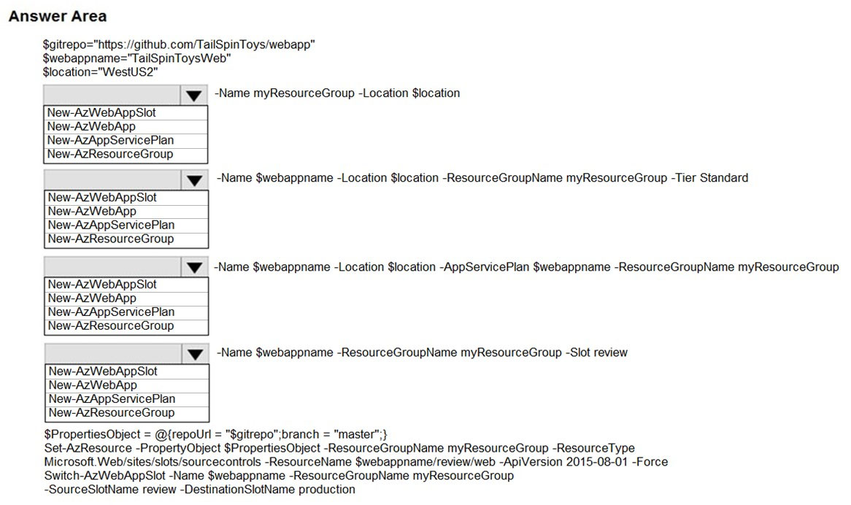

(Option 1 = A, Option 2 = B, Option 3 = C, Option 4 = D)

# Answer

D, C, B, A

1. New-AzResourceGroup
2. New-AzAppServicePlan
3. New-AzWebApp
4. New-AzWebAppSlot

# Explanation

# Question 23

You are developing a web app that is protected by Azure Web Application Firewall (WAF). All traffic to the web app is routed through an Azure Application

Gateway instance that is used by multiple web apps. The web app address is contoso.azurewebsites.net.

All traffic must be secured with SSL. The Azure Application Gateway instance is used by multiple web apps.

You need to configure the Azure Application Gateway for the web app.

Which two actions should you perform? Each correct answer presents part of the solution.

NOTE: Each correct selection is worth one point.

|  |  |
| --- | --- |
| **A** | In the Azure Application Gateway’s HTTP setting, enable the Use for App service setting. |
| **B** | Convert the web app to run in an Azure App service environment (ASE). |
| **C** | Add an authentication certificate for contoso.azurewebsites.net to the Azure Application Gateway. |
| **D** | In the Azure Application Gateway’s HTTP setting, set the value of the Override backend path option to contoso.azurewebsites.net. |

# Answer

A, D

# Explanation:

D: The ability to specify a host override is defined in the HTTP settings and can be applied to any back-end pool during rule creation.

The ability to derive the host name from the IP or FQDN of the back-end pool members. HTTP settings also provide an option to dynamically pick the host name from a back-end pool member's FQDN if configured with the option to derive host name from an individual back-end pool member.

A (not C): SSL termination and end-to-end SSL with multi-tenant services.

In case of end-to-end SSL, trusted Azure services such as Azure App service web apps do not require whitelisting the backends in the application gateway. Therefore, there is no need to add any authentication certificates.

<https://docs.microsoft.com/en-us/azure/application-gateway/application-gateway-web-app-overview>

# Question 24

You are building a website that uses Azure Blob storage for data storage. You configure Azure Blob storage lifecycle to move all blobs to the archive tier after 30 days.

Customers have requested a service-level agreement (SLA) for viewing data older than 30 days.

You need to document the minimum SLA for data recovery.

Which SLA should you use?

|  |  |
| --- | --- |
| **A** | at least two days |
| **B** | between one and 15 hours |
| **C** | at least one day |
| **D** | between zero and 60 minutes |

# Answer

B

# Explanation

The archive access tier has the lowest storage cost. But it has higher data retrieval costs compared to the hot and cool tiers. Data in the archive tier can take several hours to retrieve depending on the priority of the rehydration. For small objects, a high priority rehydrate may retrieve the object from archive in under 1 hour.

Reference:

<https://docs.microsoft.com/en-us/azure/storage/blobs/storage-blob-storage-tiers?tabs=azure-portal>

# Question 25

You have an application that uses Azure Blob storage.

You need to update the metadata of the blobs.

Which three methods should you use to develop the solution? To answer, move the appropriate methods from the list of methods to the answer area and arrange them in the correct order.

Select and Place:

|  |  |
| --- | --- |
| **A** | Metadata.Add |
| **B** | SetMetadataAsync |
| **C** | FetchAttributesAsync |
| **D** | UploadFileStream |
| **E** | SetPropertiesAsync |

# Answer

C, A, B

# Explanation:

Since we're talking about updating the metadata,

- first we need to fetch it, to populate blob's properties and metadata (we want to update it - without fetching we would just set the new metadata):

FetchAttributesAsync

- second, we need to manipulate the metadatas to update them and the best fitting is

Metadata.Add

- third, we have to persist our changes. We can use a method that initiates an asynchronous operation to update the blob's metadata, which is

SetMetadataAsync

# Question 26

You develop Azure solutions.

You must connect to a No-SQL globally-distributed database by using the .NET API.

You need to create an object to configure and execute requests in the database.

Which code segment should you use?

|  |  |
| --- | --- |
| **A** | new Container(EndpointUri, PrimaryKey); |
| **B** | new Database(EndpointUri, PrimaryKey); |
| **C** | new CosmosClient(EndpointUri, PrimaryKey); |

# Answer

C

# Explanation

<https://docs.microsoft.com/en-us/azure/cosmos-db/sql-api-get-started>

# Question 27

You have an existing Azure storage account that stores large volumes of data across multiple containers.

You need to copy all data from the existing storage account to a new storage account. The copy process must meet the following requirements:

* Automate data movement.
* Minimize user input required to perform the operation.
* Ensure that the data movement process is recoverable.

What should you use?

|  |  |
| --- | --- |
| **A** | AzCopy |
| **B** | Azure Storage Explorer |
| **C** | Azure portal |
| **D** | .NET Storage Client Library |

# Answer

A

# Explanation:

You can copy blobs, directories, and containers between storage accounts by using the AzCopy v10 command-line utility.

The copy operation is synchronous so when the command returns, that indicates that all files have been copied.

Reference:

<https://docs.microsoft.com/en-us/azure/storage/common/storage-use-azcopy-blobs-copy>

# Question 28

You are developing a web service that will run on Azure virtual machines that use Azure Storage. You configure all virtual machines to use managed identities.

You have the following requirements:

* Secret-based authentication mechanisms are not permitted for accessing an Azure Storage account.
* Must use only Azure Instance Metadata Service endpoints.

You need to write code to retrieve an access token to access Azure Storage. To answer, drag the appropriate code segments to the correct locations. Each code segment may be used once or not at all. You may need to drag the split bar between panes or scroll to view content.

NOTE: Each correct selection is worth one point.

Select and Place:

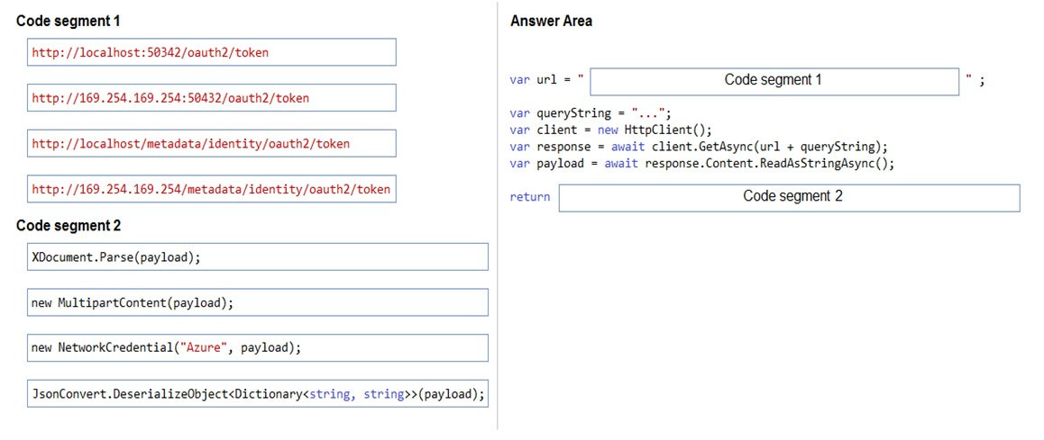

(Option 1 = A, Option 2 = B, Option 3 = C, Option 4 = D)

# Answer

D, D

Box 1: http://169.254.169.254/metadata/identity/oauth2/token

Box 2: JsonConvert.DeserializeObject<Dictionary<string,string>>(payload);

# Explanation

Azure Instance Metadata Service endpoints "/oauth2/token"

Box 1: http://169.254.169.254/metadata/identity/oauth2/token

Sample request using the Azure Instance Metadata Service (IMDS) endpoint (recommended):

GET 'http://169.254.169.254/metadata/identity/oauth2/token?api-version=2018-02-01&resource=https://management.azure.com/' HTTP/1.1 Metadata: true

Box 2: JsonConvert.DeserializeObject<Dictionary<string,string>>(payload);

Deserialized token response; returning access code.

New NetworkCredential(username, password)

# Question 29

You are building a traffic monitoring system that monitors traffic along six highways. The system produces time series analysis-based reports for each highway.

Data from traffic sensors are stored in Azure Event Hub.

Traffic data is consumed by four departments. Each department has an Azure Web App that displays the time series-based reports and contains a WebJob that processes the incoming data from Event Hub. All Web Apps run on App Service Plans with three instances.

Data throughput must be maximized. Latency must be minimized.

You need to implement the Azure Event Hub.

Which settings should you use? To answer, select the appropriate options in the answer area.

NOTE: Each correct selection is worth one point.

Number of Partitions

|  |  |
| --- | --- |
| **A** | 3 |
| **B** | 4 |
| **C** | 6 |
| **D** | 12 |

Partition Key

|  |  |
| --- | --- |
| **A** | Highway |
| **B** | Department |
| **C** | Timestamp |
| **D** | VM name |

# Answer

C, A

# Explanation

Partitions relate to **producers** - and the logical way to partition the incoming data is by the only value you have at that point, the highway name/id. So, the selected answer is correct (6 Partitions, by Highway).

People are getting confused by the departments which would actually each be an event consumer with an associated Consumer Group which would have its own isolated view of each of the highway partitions.

# Question 30

You are developing an Azure Cosmos DB solution by using the Azure Cosmos DB SQL API. The data includes millions of documents. Each document may contain hundreds of properties.

The properties of the documents do not contain distinct values for partitioning. Azure Cosmos DB must scale individual containers in the database to meet the performance needs of the application by spreading the workload evenly across all partitions over time.

You need to select a partition key.

Which two partition keys can you use? Each correct answer presents a complete solution.

NOTE: Each correct selection is worth one point.

|  |  |
| --- | --- |
| **A** | a single property value that does not appear frequently in the documents |
| **B** | a value containing the collection name |
| **C** | a single property value that appears frequently in the documents |
| **D** | a concatenation of multiple property values with a random suffix appended |
| **E** | a hash suffix appended to a property value |

# Answer

D, E

# Explanation

You can form a partition key by concatenating multiple property values into a single artificial partitionKey property. These keys are referred to as synthetic keys.

Another possible strategy to distribute the workload more evenly is to append a random number at the end of the partition key value. When you distribute items in this way, you can perform parallel write operations across partitions.

Note: It's the best practice to have a partition key with many distinct values, such as hundreds or thousands. The goal is to distribute your data and workload evenly across the items associated with these partition key values. If such a property doesn’t exist in your data, you can construct a synthetic partition key.

Reference:

<https://docs.microsoft.com/en-us/azure/cosmos-db/synthetic-partition-keys>

# Question 31

DRAG DROP -

You are developing an application to securely transfer data between on-premises file systems and Azure Blob storage. The application stores keys, secrets, and certificates in Azure Key Vault. The application uses the Azure Key Vault APIs.

The application must allow recovery of an accidental deletion of the key vault or key vault objects. Key vault objects must be retained for 90 days after deletion.

You need to protect the key vault and key vault objects.

Which Azure Key Vault feature should you use? To answer, drag the appropriate features to the correct actions. Each feature may be used once, more than once, or not at all. You may need to drag the split bar between panes or scroll to view content.

NOTE: Each correct selection is worth one point.

Select and Place:

|  |  |  |
| --- | --- | --- |
| **Enable retention period and accidental deletion** | A | Access Policy |
| B | Purge Protection |
| C | Soft delete |
| D | Shared access signature |
| **Enforce retention period and accidental deletion** | A | Access Policy |
| B | Purge Protection |
| C | Soft delete |
| D | Shared access signature |

# Answer

C, B

# Explanation

Box 1: Soft delete

When soft-delete is enabled, resources marked as deleted resources are retained for a specified period (90 days by default). The service further provides a mechanism for recovering the deleted object, essentially undoing the deletion.

This can be achieved with the help of the soft-delete feature of the key vault.

Box 2: Purge protection

Purge protection is an optional Key Vault behavior and is not enabled by default. Purge protection can only be enabled once soft-delete is enabled.

When purge protection is on, a vault or an object in the deleted state cannot be purged until the retention period has passed. Soft-deleted vaults and objects can still be recovered, ensuring that the retention policy will be followed.

This can be achieved with the help of the purge protection feature of the key vault.

# Question 32

You develop a web application. You need to register the application with an active Azure Active Directory (Azure AD) tenant. Which three actions should you perform in sequence?

To answer, set all actions from the list of actions in the correct order.

|  |  |
| --- | --- |
| **A** | Select **Manifest** from the middle-tier service registration |
| **B** | In Enterprise Applications, select **New application** |
| **C** | Add a Cryptographic key |
| **D** | Create a new application and provide the name, account type, and redirect URL |
| **E** | Select the Azure AD instance |
| **F** | Use an access token to access the secure resource |
| **G** | In App Registrations, select **New Registration** |

# Answer

E, G, D

# Explanation

# Question 33

Your company is developing an Azure API hosted in Azure.

You need to implement authentication for the Azure API to access other Azure resources. You have the following requirements:

* All API calls must be authenticated.
* Callers to the API must not send credentials to the API.

Which authentication mechanism should you use?

|  |  |
| --- | --- |
| **A** | Basic |
| **B** | Anonymous |
| **C** | Managed identity |
| **D** | Client certificate |

# Answer

C

# Explanation

Azure Active Directory Managed Service Identity (MSI) gives your code an automatically managed identity for authenticating to Azure services, so that you can keep credentials out of your code.

Note: Use the authentication-managed-identity policy to authenticate with a backend service using the managed identity. This policy essentially uses the managed identity to obtain an access token from Azure Active Directory for accessing the specified resource. After successfully obtaining the token, the policy will set the value of the token in the Authorization header using the Bearer scheme.

Incorrect Answers:

A: Use the authentication-basic policy to authenticate with a backend service using Basic authentication. This policy effectively sets the HTTP Authorization header to the value corresponding to the credentials provided in the policy.

B: Anonymous is no authentication at all.

D: Your code needs credentials to authenticate to cloud services, but you want to limit the visibility of those credentials as much as possible. Ideally, they never appear on a developers workstation or get checked-in to source control. Azure Key Vault can store credentials securely so they aren’t in your code, but to retrieve them you need to authenticate to Azure Key Vault. To authenticate to Key Vault, you need a credential! A classic bootstrap problem.

# Question 34

HOTSPOT -

You are building a website to access project data related to teams within your organization. The website does not allow anonymous access. Authentication is performed using an Azure Active Directory (Azure AD) app named internal.

The website has the following authentication requirements:

* Azure AD users must be able to login to the website.
* Personalization of the website must be based on membership in Active Directory groups.

You need to configure the application's manifest to meet the authentication requirements.

How should you configure the manifest? To answer, select the appropriate configuration in the answer area.

NOTE: Each correct selection is worth one point.

Hot Area:

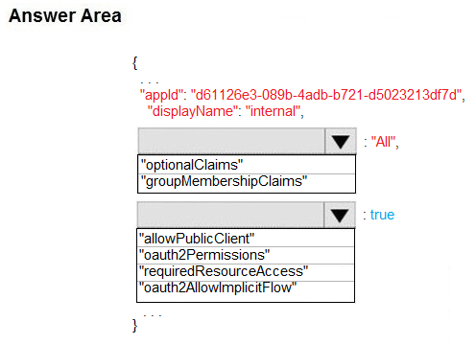

(Option 1 = A, Option 2 = B, Option 3 = C, Option 4 = D)

# Answer

B, B (groupMembershipClaims, oauth2Permissions)

# Explanation

Box 1: groupMembershipClaims -

Scenario: Personalization of the website must be based on membership in Active Directory groups.

Group claims can also be configured in the Optional Claims section of the Application Manifest.

Enable group membership claims by changing the groupMembershipClaim

The valid values are:

"All"

"SecurityGroup"

"DistributionList"

"DirectoryRole"

Box 2: oauth2Permissions -

Scenario: Azure AD users must be able to login to the website. oauth2Permissions specifies the collection of OAuth 2.0 permission scopes that the web API (resource) app exposes to client apps. These permission scopes may be granted to client apps during consent.

Incorrect Answers:

oauth2AllowImplicitFlow. oauth2AllowImplicitFlow specifies whether this web app can request OAuth2.0 implicit flow access tokens. The default is false. This flag is used for browser-based apps, like Javascript single-page apps.

# Question 35

You develop an app that allows users to upload photos and videos to Azure storage. The app uses a storage REST API call to upload the media to a blob storage account named Account1. You have blob storage containers named Container1 and Container2.

Uploading of videos occurs on an irregular basis.

You need to copy specific blobs from Container1 to Container2 when a new video is uploaded.

What should you do?

|  |  |
| --- | --- |
| **A** | Copy blobs to Container2 by using the Put Blob operation of the Blob Service REST API |
| **B** | Create an Event Grid topic that uses the Start-AzureStorageBlobCopy cmdlet |
| **C** | Use AzCopy with the Snapshot switch to copy blobs to Container2 |
| **D** | Download the blob to a virtual machine and then upload the blob to Container2 |

# Answer

B

# Explanation

The Start-AzureStorageBlobCopy cmdlet starts to copy a blob.

Example 1: Copy a named blob -

C:\PS>Start-AzureStorageBlobCopy -SrcBlob "ContosoPlanning2015" -DestContainer "ContosoArchives" -SrcContainer "ContosoUploads"

This command starts the copy operation of the blob named ContosoPlanning2015 from the container named ContosoUploads to the container named

ContosoArchives.

# Question 36

You develop and deploy an Azure Logic app that calls an Azure Function app. The Azure Function app includes an OpenAPI (Swagger) definition and uses an

Azure Blob storage account. All resources are secured by using Azure Active Directory (Azure AD).

The Azure Logic app must securely access the Azure Blob storage account. Azure AD resources must remain if the Azure Logic app is deleted.

You need to secure the Azure Logic app.

What should you do?

|  |  |
| --- | --- |
| **A** | Create a user-assigned managed identity and assign role-based access controls. |
| **B** | Create an Azure AD custom role and assign the role to the Azure Blob storage account. |
| **C** | Create an Azure Key Vault and issue a client certificate. |
| **D** | Create a system-assigned managed identity and issue a client certificate. |
| **E** | Create an Azure AD custom role and assign role-based access controls. |

# Answer

A

# Explanation

To give a managed identity access to an Azure resource, you need to add a role to the target resource for that identity.

Note: To easily authenticate access to other resources that are protected by Azure Active Directory (Azure AD) without having to sign in and provide credentials or secrets, your logic app can use a managed identity (formerly known as Managed Service Identity or MSI). Azure manages this identity for you and helps secure your credentials because you don't have to provide or rotate secrets.

If you set up your logic app to use the system-assigned identity or a manually created, user-assigned identity, the function in your logic app can also use that same identity for authentication.

# Question 37

HOTSPOT -

You are developing an Azure App Service hosted ASP.NET Core web app to deliver video-on-demand streaming media. You enable an Azure Content Delivery Network (CDN) Standard for the web endpoint.

Customer videos are downloaded from the web app by using the following example URL: http://www.contoso.com/ content.mp4?quality=1

All media content must expire from the cache after one hour. Customer videos with varying quality must be delivered to the closest regional point of presence (POP) node.

You need to configure Azure CDN caching rules.

Which options should you use? To answer, select the appropriate options in the answer area.

NOTE: Each correct selection is worth one point.

Hot Area:

|  |  |  |
| --- | --- | --- |
| **Caching behavior** | A | Bypass cache |
| B | Override |
| C | Set if missing |
| **Cache expiration duration** | A | 1 second |
| B | 1 minute |
| C | 1 hour |
| D | 1 day |
| **Query string caching behavior** | A | Ignore query strings |
| B | Bypass caching for query strings |
| C | Cache every unique URL |

# Answer

B, C, C

# Explanation

Override: Ignore origin-provided cache duration; use the provided cache duration instead. This will not override cache-control: no-cache.

Set if missing: Honor origin-provided cache-directive headers, if they exist; otherwise, use the provided cache duration.

Incorrect:

Bypass cache: Do not cache and ignore origin-provided cache-directive headers.

All media content must expire from the cache after one hour.

Cache every unique URL: In this mode, each request with a unique URL, including the query string, is treated as a unique asset with its own cache. For example, the response from the origin server for a request for example.ashx?q=test1 is cached at the POP node and returned for subsequent caches with the same query string. A request for example.ashx?q=test2 is cached as a separate asset with its own time-to-live setting.

Incorrect Answers:

Bypass caching for query strings: In this mode, requests with query strings are not cached at the CDN POP node. The POP node retrieves the asset directly from the origin server and passes it to the requestor with each request.

Ignore query strings: Default mode. In this mode, the CDN point-of-presence (POP) node passes the query strings from the requestor to the origin server on the first request and caches the asset. All subsequent requests for the asset that are served from the POP ignore the query strings until the cached asset expires.

# Question 38

A company is developing a gaming platform. Users can join teams to play online and see leaderboards that include player statistics. The solution includes an entity named Team.

You plan to implement an Azure Redis Cache instance to improve the efficiency of data operations for entities that rarely change.

You need to invalidate the cache when team data is changed.

How should you complete the code? To answer, select the appropriate options in the answer area.

NOTE: Each correct selection is worth one point.

void ClearCachedTemas()

{

|  |  |
| --- | --- |
| **A** | IDatabase cache = Connection.GetDatabase(); |
| **B** | ICache cache = Connection.GetDatabase(); |

|  |  |
| --- | --- |
| **A** | cache.KeyDelete(“Team”) |
| **B** | cache.StringSet(“Team”, “”); |
| **C** | cache.ValueDelete(“Team”); |
| **D** | cache.StringGet(“Team”, “”); |

ViewBag.msg = “Team data removed from cache.”

}

# Answer

A, A

# Explanation

# Question 39

You are developing and deploying several ASP.NET web applications to Azure App Service. You plan to save session state information and HTML output.

You must use a storage mechanism with the following requirements:

* Share session state across all ASP.NET web applications.
* Support controlled, concurrent access to the same session state data for multiple readers and a single writer.
* Save full HTTP responses for concurrent requests.

You need to store the information.

Proposed Solution: Deploy and configure Azure Cache for Redis. Update the web applications.

Does the solution meet the goal?

|  |  |
| --- | --- |
| **A** | Yes |
| **B** | No |

# Answer

A

# Explanation

The session state provider for Azure Cache for Redis enables you to share session information between different instances of an ASP.NET web application.

The same connection can be used by multiple concurrent threads.

Redis supports both read and write operations.

The output cache provider for Azure Cache for Redis enables you to save the HTTP responses generated by an ASP.NET web application.

Note: Using the Azure portal, you can also configure the eviction policy of the cache, and control access to the cache by adding users to the roles provided. These roles, which define the operations that members can perform, include Owner, Contributor, and Reader. For example, members of the Owner role have complete control over the cache (including security) and its contents, members of the Contributor role can read and write information in the cache, and members of the

Reader role can only retrieve data from the cache.

# Question 40

You are developing applications for a company. You plan to host the applications on Azure App Services.

The company has the following requirements:

* Every five minutes verify that the websites are responsive.
* Verify that the websites respond within a specified time threshold. Dependent requests such as images and JavaScript files must load properly.
* Generate alerts if a website is experiencing issues.
* If a website fails to load, the system must attempt to reload the site three more times.

You need to implement this process with the least amount of effort.

What should you do??

|  |  |
| --- | --- |
| **A** | Create a Selenium web test and configure it to run from your workstation as a scheduled task. |
| **B** | Set up a URL ping test to query the home page. |
| **C** | Create an Azure function to query the home page. |
| **D** | Create a multi-step web test to query the home page. |
| **E** | Create a Custom Track Availability Test to query the home page. |

# Answer

B

# Explanation

A. Selenium is an umbrella project for a range of tools and libraries that enable and support the automation of web browsers.

It provides extensions to emulate user interaction with browsers, a distribution server for scaling browser allocation, and the infrastructure for implementations of the W3C WebDriver specification that lets you write interchangeable code for all major web browsers.

C: Can work but is too complex

D: Will work if you need VS enterprise. Besides it is deprecated and too complex

E: Too complex

# Question 41

A company is developing a solution that allows smart refrigerators to send temperature information to a central location.

The solution must receive and store messages until they can be processed. You create an Azure Service Bus instance by providing a name, pricing tier, subscription, resource group, and location.

You need to complete the configuration.

Which Azure CLI or PowerShell command should you run?

|  |  |
| --- | --- |
| **A** | az servicebus queue create --resource-group fridge-rg --namespace-name fridge-ns --name fridge-q |
| **B** | New-AzureRmResourceGroup –Name fridge-rg –Location fridge-loc |
| **C** | az servicebus namespace create --resource-group fridge-rg --name fridge-ns --location fridge-loc |
| **D** | connectionString=$(az servicebus namespace authorization-rule keys list --resource-group $resourceGroupName --namespace-name $namespaceName --name  RootManageSharedAccessKey --query primaryConnectionString --output tsv) |

# Answer

A

# Explanation

Servicebus namespace is already created so the only thing left todo is to create a queue

# Question 42

You are developing an Azure messaging solution.

You need to ensure that the solution meets the following requirements:

* Provide transactional support.
* Provide duplicate detection.
* Store the messages for an unlimited period of time.

Which two technologies will meet the requirements? Each correct answer presents a complete solution.

NOTE: Each correct selection is worth one point.

|  |  |
| --- | --- |
| **A** | Azure Service Bus Topic |
| **B** | Azure Service Bus Queue |
| **C** | Azure Storage Queue |
| **D** | Azure Event Hub |

# Answer

A, B

# Explanation

The Azure Service Bus Queue and Topic has duplicate detection.

Enabling duplicate detection helps keep track of the application-controlled MessageId of all messages sent into a queue or topic during a specified time window.

Incorrect Answers:

C: There is just no mechanism that can query a Storage queue and find out if a message with the same contents is already there or was there before.

D: Azure Event Hub does not have duplicate detection

Reference:

<https://docs.microsoft.com/en-us/azure/service-bus-messaging/duplicate-detection>

# Question 43

You are developing an Azure solution to collect point-of-sale (POS) device data from 2,000 stores located throughout the world. A single device can produce

2 megabytes (MB) of data every 24 hours. Each store location has one to five devices that send data.

You must store the device data in Azure Blob storage. Device data must be correlated based on a device identifier. Additional stores are expected to open in the future.

You need to implement a solution to receive the device data.

Solution: Provision an Azure Event Hub. Configure the machine identifier as the partition key and enable capture.

Does the solution meet the goal?

|  |  |
| --- | --- |
| **A** | Yes |
| **B** | No |

# Answer

B

# Explanation

Partition size cannot exceed 1024. We have way more devices

# Question 44

Your company has an Azure subscription.

You need to deploy a number of Azure virtual machines to the subscription by using Azure Resource Manager (ARM) templates. The virtual machines will be included in a single availability set.

You need to ensure that the ARM template allows for as many virtual machines as possible to remain accessible in the event of fabric failure or maintenance.

Which of the following is the value that you should configure for the platformFaultDomainCount property?

|  |  |
| --- | --- |
| **A** | 10 |
| **B** | 30 |
| **C** | Min Value |
| **D** | Max Value |

# Answer

D

# Explanation

The number of fault domains for managed availability sets varies by region - either two or three per region.

Values can be 1,2 or 3. Max Value is 3

# Question 45

Your company has an Azure subscription.

You need to deploy a number of Azure virtual machines to the subscription by using Azure Resource Manager (ARM) templates. The virtual machines will be included in a single availability set.

You need to ensure that the ARM template allows for as many virtual machines as possible to remain accessible in the event of fabric failure or maintenance.

Which of the following is the value that you should configure for the platformUpdateDomainCount property?

|  |  |
| --- | --- |
| **A** | 10 |
| **B** | 20 |
| **C** | 30 |
| **D** | 40 |

# Answer

B

# Explanation

Each availability set can be configured with up to three fault domains and twenty update domains.

# Question 46

You are developing an e-Commerce Web App.

You want to use Azure Key Vault to ensure that sign-ins to the e-Commerce Web App are secured by using Azure App Service authentication and Azure Active

Directory (AAD).

What should you do on the e-Commerce Web App?

|  |  |
| --- | --- |
| **A** | Run the az keyvault secret command. |
| **B** | Enable Azure AD Connect. |
| **C** | Enable Managed Service Identity (MSI). |
| **D** | Create an Azure AD service principal. |

# Answer

C

# Explanation

A managed identity from Azure Active Directory allows your app to easily access other AAD-protected resources such as Azure Key Vault.

# Question 47

You are developing a REST web service. Customers will access the service by using an Azure API Management instance.

The web service does not correctly handle conflicts. Instead of returning an HTTP status code of 409, the service returns a status code of 500. The body of the status message contains only the word conflict.

You need to ensure that conflicts produce the correct response.

How should you complete the policy? To answer, drag the appropriate code segments to the correct locations. Each code segment may be used once, more than once, or not at all. You may need to drag the split bar between panes or scroll to view content.

NOTE: Each correct selection is worth one point.

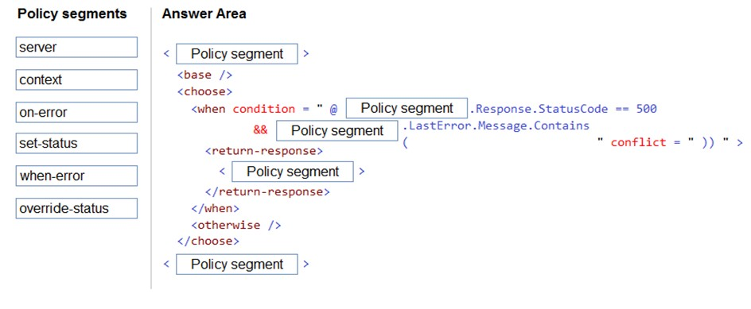

|  |  |
| --- | --- |
| **A** | server |
| **B** | context |
| **C** | on-error |
| **D** | set-status |
| **E** | when-error |
| **F** | override-status |

# Answer

C, B, B, D, C

# Explanation

Reference:

<https://docs.microsoft.com/en-us/azure/api-management/api-management-error-handling-policies>

<https://docs.microsoft.com/en-us/azure/api-management/api-management-transformation-policies>

# Question 48

You develop a Web App on a tier D1 app service plan.

You notice that page load times increase during periods of peak traffic.

You want to implement automatic scaling when CPU load is above 80 percent. Your solution must minimize costs.

What should you do first?

|  |  |
| --- | --- |
| **A** | Enable autoscaling on the Web App |
| **B** | Switch to the Premium App Service Plan |
| **C** | Switch to the Standard App Service Plan |
| **D** | Switch to the Azure App Service consumption Plan |

# Answer

C

# Explanation

Configure the web app to the Standard App Service Tier. The Standard tier supports auto-scaling, and we should minimize the cost. We can then enable autoscaling on the web app, add a scale rule and add a Scale condition.

Reference:

<https://docs.microsoft.com/en-us/azure/monitoring-and-diagnostics/monitoring-autoscale-get-started>

<https://azure.microsoft.com/en-us/pricing/details/app-service/plans/>

# Question 49

Your company's Azure subscription includes an Azure Log Analytics workspace.

Your company has a hundred on-premises servers that run either Windows Server 2012 R2 or Windows Server 2016, and is linked to the Azure Log Analytics workspace. The Azure Log Analytics workspace is set up to gather performance counters associated with security from these linked servers.

You must configure alerts based on the information gathered by the Azure Log Analytics workspace.

You have to make sure that alert rules allow for dimensions, and that alert creation time should be kept to a minimum. Furthermore, a single alert notification must be created when the alert is created and when the alert is resolved.

You need to make use of the necessary signal type when creating the alert rules.

Which of the following is the option you should use?

|  |  |
| --- | --- |
| **A** | The Activity log signal type. |
| **B** | The Application Log signal type. |
| **C** | The Metric signal type. |
| **D** | The Audit Log signal type. |

# Answer

C

# Explanation

Metric alerts in Azure Monitor provide a way to get notified when one of your metrics cross a threshold. Metric alerts work on a range of multi-dimensional platform metrics, custom metrics, Application Insights standard and custom metrics.

Note: Signals are emitted by the target resource and can be of several types. Metric, Activity log, Application Insights, and Log.

Reference:

<https://docs.microsoft.com/en-us/azure/azure-monitor/platform/alerts-metric>

# Question 50

You have an application that provides weather forecasting data to external partners. You use Azure API Management to publish APIs.

You must change the behavior of the API to meet the following requirements:

* Support alternative input parameters
* Remove formatting text from responses
* Provide additional context to back-end services

Which types of policies should you implement? To answer, drag the policy types to the correct scenarios. Each policy type may be used once, more than once, or not at all. You may need to drag the split bar between panes or scroll to view content.

NOTE: Each correct selection is worth one point.

Select and Place:

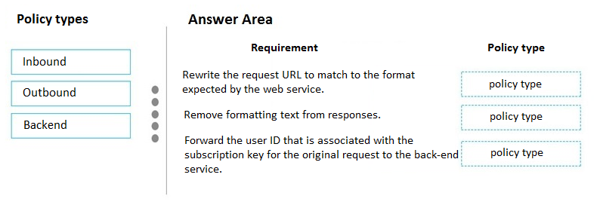

|  |  |
| --- | --- |
| **A** | Inbound |
| **B** | Outbound |
| **C** | Backend |

# Answer

A, B, A

# Explanation

A) (Inbound) Manipulate incoming request

B (Outbound) You need to manipulate a response

A (inbound). See <https://github.com/Azure/api-management-policy-snippets/blob/master/examples/Send%20request%20context%20information%20to%20the%20backend%20service.policy.xml>